SWAP – Let’s make a tiny canteen!

Supplies –

Bottle cap

Pony Bead

Foam Strip or ribbon

Safety Pin

Glue

Glue the pony bead to the side of the bottle cap.

Glue the strip of foam on either side of the pony bead.

Add your safety pin.

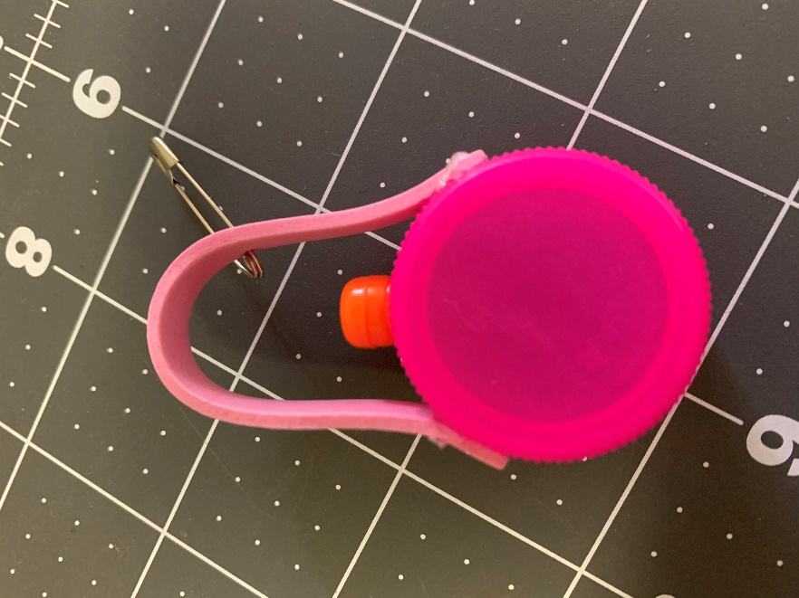

Activity – Make fun out of lunch. Sometimes, playing with your food is okay. See what ingredients you can use to make an artful meal.

